Initial Project Proposal

Year: 2017 Semester: Spring

Project Name: Barbot

Creation Date:October 31, 2016 Last Modified: October 31, 2016

Team Members (#1 is Team Leader):

Member 1: Yudi Wu Email: [wu553@purdue.edu](mailto:wu553@purdue.edu)

Member 2: Mengshi Feng Email: feng96@purdue.edu

Member 3: Junjie Wang Email: wang1764@purdue.edu

Member 4: Siyi Cai Email: cai71@purdue.edu

1.0 Description of Problem:

People loves to hold party at home, but most of time family can’t afford money to hire a bartender. At the same time, “In 2012, 8.2 percent of all Americans were considered heavy drinkers and 18.3 percent were binge drinkers," the University of Washington's Institute for Health Metrics and Evaluation says in a statement. People love drinking alcohol. If people could enjoy different kinds of cocktails or alcoholic drinking at home, people will saves a lot of money, and they can enjoy delicious cocktails and hang out with friends at home, where is a more comfortable and relaxed space. Bars combat countless difficulties as a result of the need to hire human bartenders. For instance, each bartender can only remember a finite number of drink orders at once. In addition, bartenders cost bar owners an hourly wage. Additional issues customers face may range from uncertainty in the types of drinks and shyness in ordering the specific type of drink they want. The automatic bartender circumvents all these problems to deliver a fun drinking experience.

2.0 Proposed Solution:

We are going to build an automatic bartender. We decided to construct website user interface. People can go to the website by scanning QR code. In the interface, people could choose different kind of drinks from the menu they wish to purchase, also, people can DIY their own cocktail by choosing different drink and the volume as they want. The chosen drink will then be automatically piped from the required internal canisters and, if the drink is composed of more two or more liquids,they will be combined before displaying the finished product to the customer.

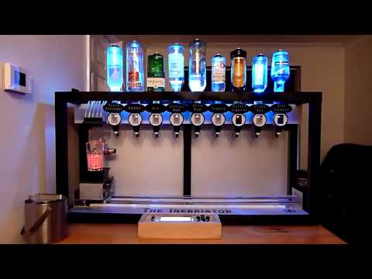

3.0 ECE 477 Course Requirements Satisfaction

3.1 Expected Microcontroller Responsibilities

Wireless control, data storage and heavy-duty computation are handled by a raspberry Pi, thus most of jobs the microcontroller would have are controlling the hardware. The microcontroller in the barbot will have the following responsibilities:

* Receive and process the sequence of drinks need to be mixed from the raspberry Pi. Raspberry Pi would receive the desired product name from the user, and then it would send the sequence of drinks need to be mixed to the microcontroller one by one.
* Move the drink platform to the desired location by instructing the stepper motor
* Instruct the motorized lifter to open the drink dispenser
* Control the light effect and the light brightness
* Power a LCD to display the current process and the process status

3.2 Expected Printed Circuit Responsibilities

The product need a PCB that must handle many responsibilities. There will need to be connections between the battery and all of the components on the circuit board that will require power, as will as connections to the microcontroller and the Raspberry Pi. The power would be either a 12V wall charger or a 12V battery. A 5V regulator would be used for the power supply for all logic circuits. The PCB will also need to connect the LCD to display the information.

4.0 Market Analysis:

The potential market for this product is for any establishment that sells alcohol. It could be marketed to both crowd bars in busy areas or home use. For crowd bars, the bartender, i.e., the person who serves patrons at the counter, at times of maximum crowding of the place is often overwhelmed by orders and therefore the waiting times for serving a patron can be long. In order to facilitate the work of bartenders, dispensers which allow to speed up the step of dispensing the beverages into glasses have been known for many years. These dispensers are constituted generally by a plurality of reservoirs of beverages (typically soft drinks, but not only), each of which has discharge ducts which end above a glass filling area. For personal users, our product can help them prepare the drink in a easy way. They don’t need to worry about forgetting the recipe for cocktail wine. They can simply type in the name of the cocktail and wait the cocktail to come out. Since it is portable and convenient, it also can be carried and used in multiple places.

5.0 Competitive Analysis:

5.1 Preliminary Patent Analysis:

There seems to be a lot of relevant intellectual property very similar to our proposed idea. Some of the most applicable are described below.

5.1.1 Patent #1:

**Patent Title:** “Automatic bar”

**Patent Holder:** Mauro Leoni

**Patent Filing Date:** February 22nd, 2000

A device for automatic preparation of mixed and non-mixed beverages comprises, on a load-bearing structure , a conveyor designed to convey one or more containers for mixed and non-mixed beverages, and at least one motor-driven rotary head which carries a plurality of receptacles for the ingredients to be poured into the containers, each one of the receptacles being equipped with an automatic-dosing actuation valve, and to the said device there being associated an automatic system for managing mutual positioning between the containers and the automatic-dosing actuation valves.

5.1.2 Patent #2:

**Patent Title:** “Automatic cocktail-bar”

**Patent Holder:** Massimo Baldin, Luca Cornolo’, Michele Gasparoni

**Patent Filing Date:** May 9th, 2006

A beverage dispenser comprising, in association with beverage containers, means for discharging the beverage from each container to a filling area for at least one glass; liquid flow control valves being associated with the beverage discharge means. The beverage dispenser also comprises means for measuring the amount of beverage dispensed by way of the discharge means and an electronic control unit, which is provided with a user interface and is functionally connected to the liquid flow control valves (24) and to the measurement means; the electronic control unit is adapted to manage the flows of dispensed beverage, accordingly allowing to make cocktails and monitor the quantities of beverages and types of cocktail that are dispensed.

5.1.3 Patent #3:

**Patent Title:** “Automatic drinks vending machine”

**Patent Holder:** Gelato Quick S.a.s. di A. Giorgetti & C.

**Patent Filing Date:** March 31, 1998

This patent, describes a method of mixing internal liquids with external, purified water. Our design, however, draws liquids from the internal tanks and mixes said liquids with themselves instead of mixing said internal liquids with external sources, avoiding patent infringement. The downside of this patent, though, seems to be that the casing, seen in figure 5.1.3.2, in which the internals are placed is very large, taking up a lot of room in whatever building it is to be placed in. Additionally, its reliance on an external water connection requires either piping or a soft water line to be drawn to the machine and connected at all times.

5.2 Commercial Product Analysis:

There seems to be a lot of relevant intellectual property very similar to our proposed idea. Some of the most applicable are described below.

5.2.1 B7

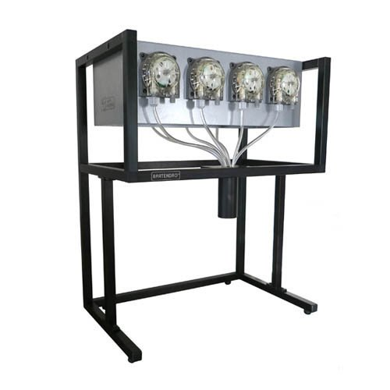

The B7 employs 7 sophisticated peristaltic pumps that work in unison to dispense accurate, repeatable cocktails. Use any web-enabled tablet or smartphone to select cocktails from a menu that only shows the drinks available to be made. In the administration back-end, new ingredients can be added to the list and those ingredients can be used to custom create new drinks, or modify existing ones. Save your favorites and discover new ones! This system is sanitary because ingredients don’t flow through any moving parts, so it’s easy to disassemble all the tubing and clean as necessary.

Bartendro is perfect for many environments. Whether for home or business, Bartendro classes up the setting with its modern looks and showy personality. This bot is perfect for anything from a small party to large events, from the office to a wedding, a small restaurant to an ultra-busy nightclub. Making several hundred drinks in an evening is no sweat. Save money by reducing messiness, wasted alcohol and time.

5.2.2 Somabar:

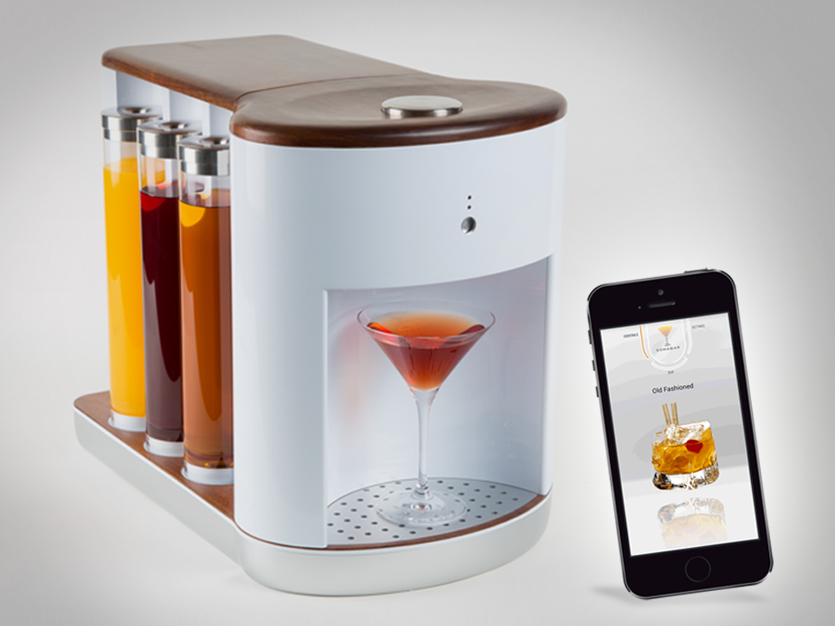

Customer can customize drinks for user created cocktail concoctions, and there are 6 refill soma pods(3 on either side) which are removable, diswasher-safe and portable.Fully mixes cocktails before dispensing.

5.2.3 The Barkeeper

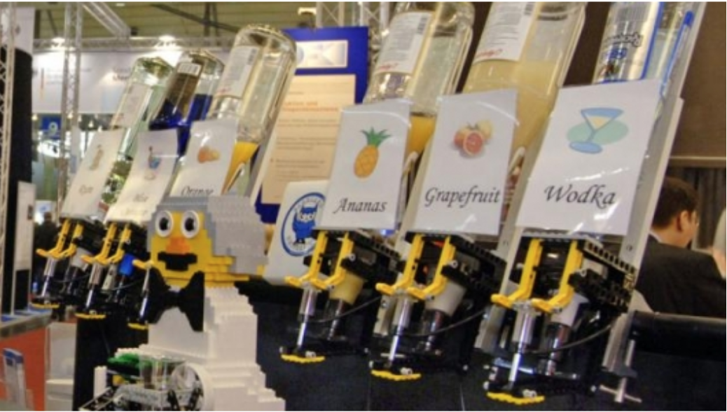

The Barkeeper is a scholastic undertaking rather than a commercial one. It was created by Linguistics students in Germany, and is primarily constructed of LEGOs. The Barkeeper has several advantages over the proposed design. Its primary purpose was to realize the value of the integration of Linguistics into robotics, and as a result the Barkeeper’s grasp of language is far superior to that of the proposed device. It includes not only a quasi-artificially intelligent structure which allows it to comprehend human language (drink orders), but also harbors a database of alcohol-themed jokes. However, it has the disadvantage of excessive mechanical movement, which prevents it from mixing large drinks. The point was to approximate the movements of a human bartender, but the robot is unable to mimic these movements except for small amounts of liquid. The design proposed here will not have that flaw, as pipes will be used in place of syringes to funnel liquid and mechanical movement will be minimal. However, the linguistic aspect can be adapted to the proposed project to add allure,such as providing jokes or some other entertainment to the user as they procure their beverage.

5.3 Open Source Project Analysis:

*In this section, some basic searching should be performed for competing educational, research, and open-source projects. Replace section titles with relevant title of products (see example project proposal for additional information). Inclusion of a picture that helps describe the project is helpful and recommended. Particularly valuable from an engineering perspective is any technical information that can be obtained on how the projects work; this will allow you to evaluate the projects and compare technical approaches. Any details about the licenses of open source projects are particularly valuable to know (Do the licenses require share-alike or that derivatives also be open source? Do they allow commercial use?). Discuss the pros and cons of the project compared to your proposed solution (particularly those which are technical and nature). Discuss anything that might be adapted from a given project to help improve your own solution.*

5.3.1 Somabot

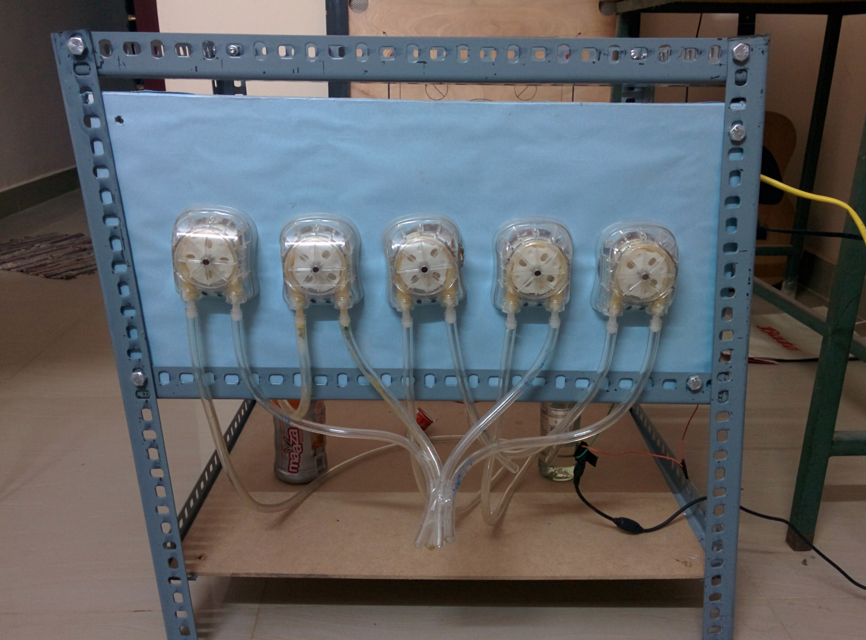

The Somabot is an homemade open source project created by a hobbyist. I found the information about the project through github.com and another image website called imgur.com. The Somabot use has very advanced website application that could be able to access on any browser on either desktop or mobile device. The Raspberry Pi is used as hardware interface with web-app. It uses five peristaltic pumps to pump five different kinds of beverages up and drop them down through plastic pipes. Once users select their desired mix of drink, the corresponding peristaltic pumps will start working simultaneously and pour down the desired mix. One really cool part of this project is that it uses an NFC chip on the top of the supporting board so that the website application will automatically open up once the user's’ mobile device approaches the board. The project has the similarity with proposed project on website application involvement. However, the physical pipe would not be able to control the amount of liquid that is pouring down, which will result in the wrong mix of drink. Our proposed solution will handle this by using liquid dispenser, which will lead us to the advantages of more precisely control of beverage proportion.

The Somabot is totally open source and is not for commercial purpose of use.

5.3.2 The Drink Maker

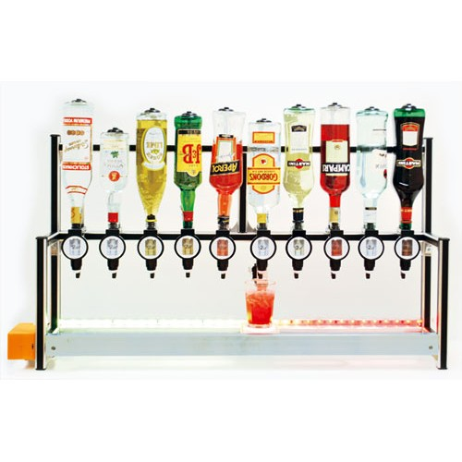

The Drink Maker has more similarities with our proposed idea, user could use order their desired drink mix through web-based application and the drink machine will make the drink for them automatically. As for as the technical functionality, the Drink Maker has an webpage to provide user interface and an administration system to provide transparent customer order management system. So it basically simulates the order process of purchasing a drink, and it also indicates the potential commercial use in bar. The project is based on RandA, which is the integrated board that contains both Raspberry Pi and Atmega328 microcontroller. The robot machine uses frame composed of aluminum profiles, on which are applied in a row of the dispenser with push-button actuating rear, pressed by a lever controlled by a servomotor. Each dispenser every time it presses the drive delivers a predetermined quantity of beverage (20 ml) and once the quantity of beverage is poured down, the dispenser will fetch new 20 ml liquid from the bottle on the top.

The Barbot will have the similar implementation with the Drink Maker, except for that we won’t implement administration system which means we will not attempt to simulate the drink purchase process. We will only provide web-based interface for user to choose their desired recipe. Our design will pay additional attention to avoid the glass cup move so fast beneath the bottles that the liquid will spill out, we will make sure that the carrier speeds up progressively from its slow starting speed, and takes around 1 second to achieve its maximum speed.

The Drink Maker is a completely open source project, all the codes are available on github.com, however, they do sell their product on store.open-electronics.org. But they do have the intention to inspire more people since they have complete tutorial of the implementation of their project for both hardware and software.

5.3.3 Bartendro

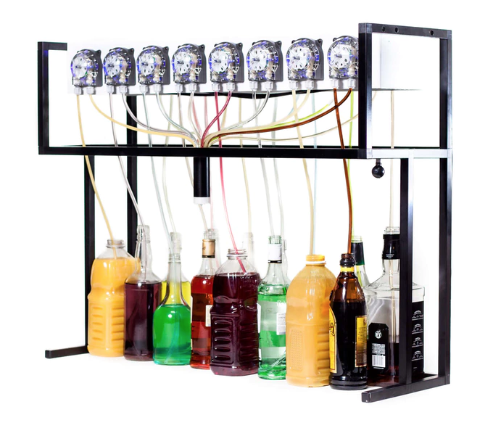

The Bartendro is a self-contained drink mixer which automatically mixes cocktails for the user. The Bartendro uses sixteen peristaltic pumps to push liquid up from sixteen bottles, through pipes, and into a waiting cup. The microcontroller that it used was the Arduino. The WiFi dongle is also provided to get user input from their cellphone.

Both Bartendro and Barbot are designed for home parties use. Instead of using pumps and pipes, Barbot uses stepper motor to move the glass along the trolley to the desired place. And inject the drink into waiting cup once the pushbutton of dispenser is pressed. This process is more fancier than the process of just pumping the beverage into pipes. This gives more enjoyment when it is used in home parties.

The Bartendro Project is open source and the creators encourage others to expand upon their original design in all imaginable ways. However, they do sell them if the quantity of order reach a large amount.

6.0 Sources Cited:

*Throughout this and other papers, use of the IEEE citation style should be used. Use of embedded hyperlinks for all web-based sources is required. A reference to the IEEE citation style format is provided* [*here*](http://www.ieee.org/documents/ieeecitationref.pdf)*.*

1. The Inebriator, 2016.[Online]. Available: <http://www.theinebriator.com/>.

2. Leoni, Mauro (2000, February 22). *Automatic bar.* Available: <https://www.google.com/patents/WO2000058200A1>

3. Baldin, Massimo and Cornolo’, Luca and Gasparoni, Michele (2006, May 9). *Automatic cocktail-bar.* Available:<https://www.google.com/patents/WO2006131431A1>

4. Gelato Quick S.a.s. di A. Giorgetti & C. (1998, March 31). *Automatic drinks vending machine.* Available:<https://www.google.com/patents/EP0947518A1>

5. P. R. Store, "Bartendro 7," in *Bartendro*, Party Robotics Store, 2016. [Online]. Available: http://partyrobotics.com/collections/products/products/bartendro-7. Accessed: Nov. 1, 2016.

5."Robotic bartender for your home," 2014. [Online]. Available: http://www.somabarkickstarter.com. Accessed: Nov. 1, 2016.

6. Somabot, 2016.[Online] Availiable: <https://imgur.com/a/pUxuG#ihqLLIa>

7. M. Bellan, "DrinkMaker with 5 dispensers," in OpenElectronics, Open-electronics.org Store by Futura Group, 2016. [Online]. Available: https://store.open-electronics.org/index.php?_route_=DRINKMAKER. Accessed: Nov. 1, 2016.

8. M. Bellan, "The soul of the open source automatic bartender: The DRINK MAKER software," inOpenElectronics, Open Electronics, 2016. [Online]. Available: http://www.open-electronics.org/the-soul-of-the-open-source-automatic-bartender-the-drink-maker-software/. Accessed: Nov. 1, 2016.

9. "Bartendro - A Cocktail Dispensing Robot," in KickStarers, 2013. [Online]. Available: https://www.kickstarter.com/projects/partyrobotics/bartendro-a-cocktail-dispensing-robot. Accessed: Nov. 1, 2016.

Appendix 1: Concept Sketch

*Provide one or more drawings of your proposed finished project. Scanned copies of hand-drawn sketches are acceptable.*

